Image | 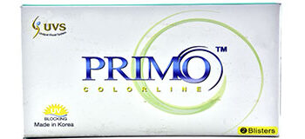
Brand | DIOR
Model Name | PRIMO
Price | RS 2500
PRODUCT DETAILS

